Ai Aissted coding Assignment 4.4
Name:Kanneboyina Meghana
Batch:44
HTNO:2303a52345
Problem statement 1: 1. Sentiment Classification for Customer Reviews
Prompt: Classify the following email into one of the categories: High Priority, Medium Priority, or Low Priority.
a) Sample Reviews with Sentiment Labels
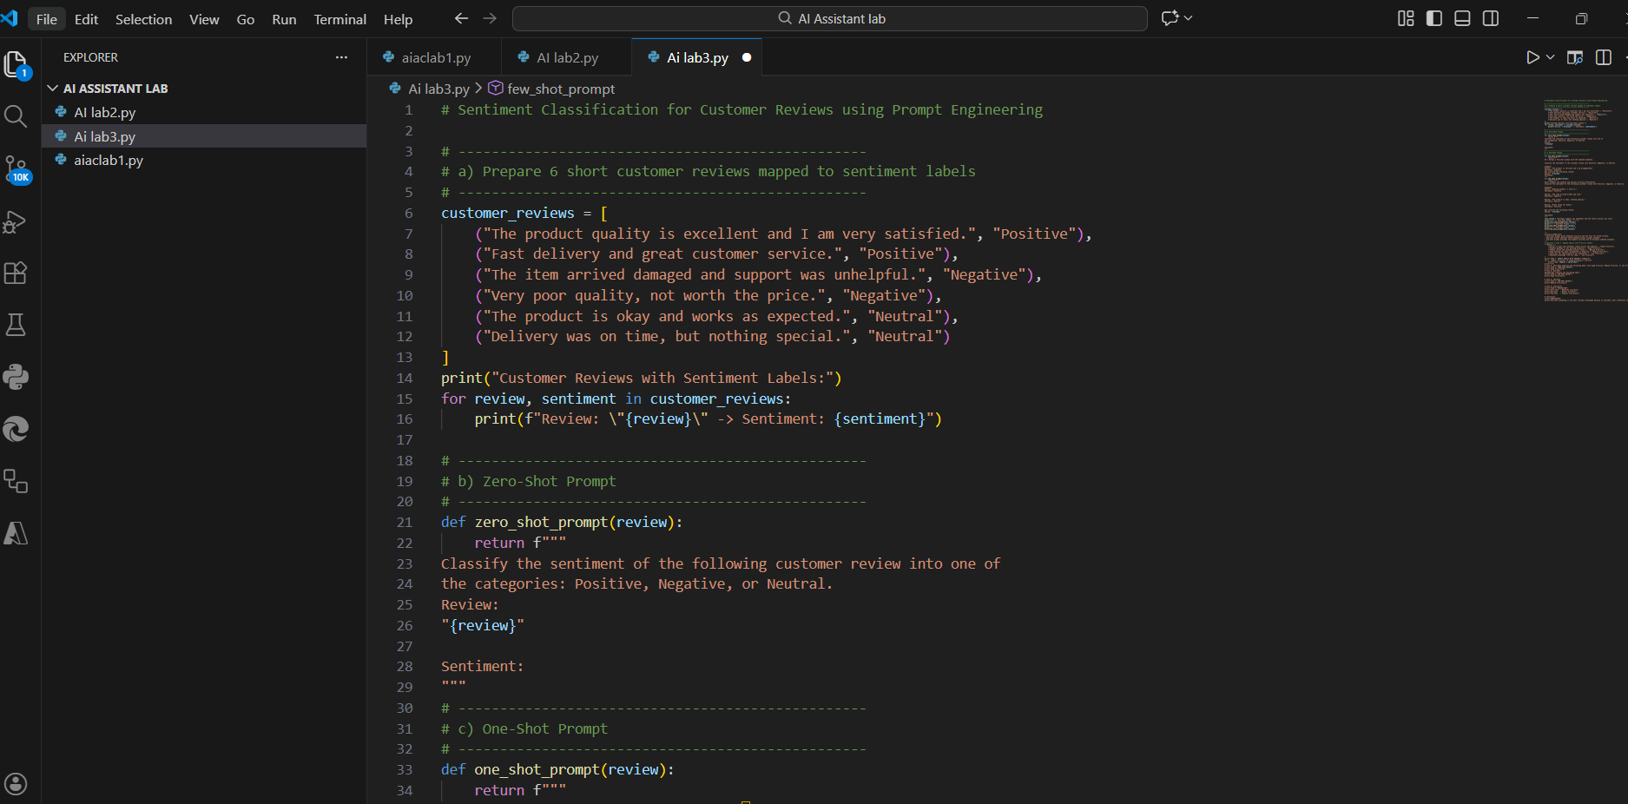
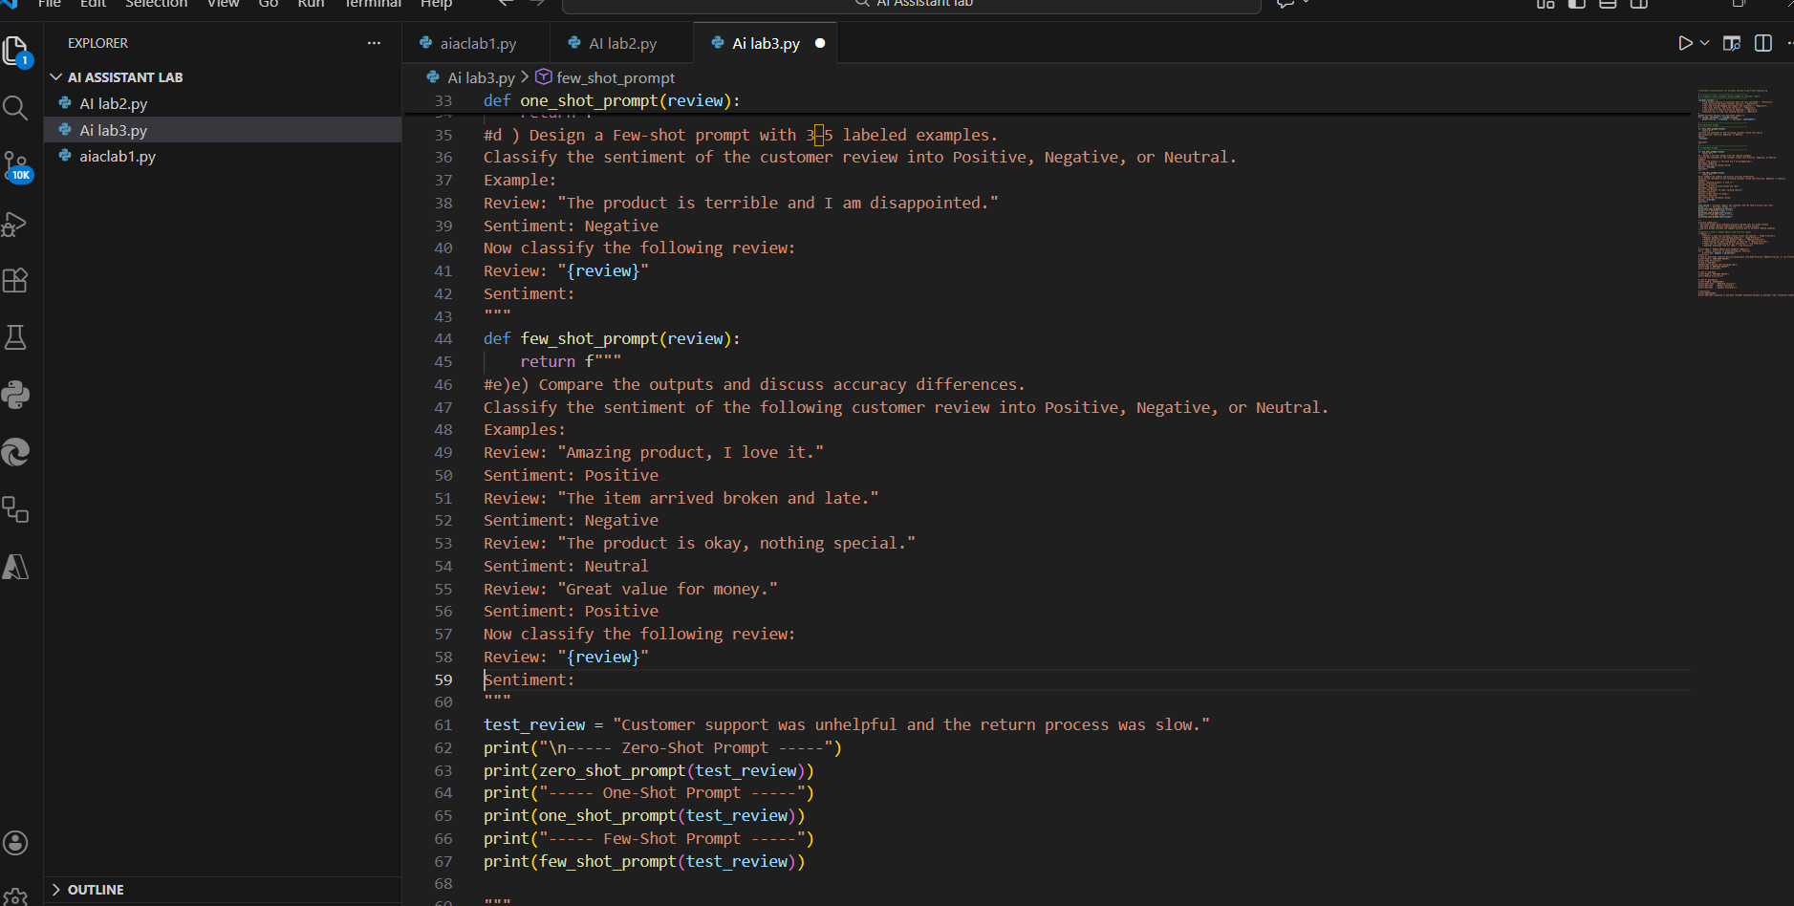

Explanation:
1. Emails are classified into High, Medium, and Low Priority based on urgency.
2. Six sample emails are created and labeled with priority levels.
3. Zero-shot prompting: No examples are given; accuracy is moderate.
4. One-shot prompting: One labeled example improves understanding.
5.Few-shot prompting: Multiple examples give the best accuracy.
6. Few-shot prompting is most reliable because it reduces ambiguity.

Problem statement 2: Email Priority Classification
Prompt: A company wants to automatically classify incoming emails into High, Medium, or Low Priority to respond efficiently.
1.Create 6 sample email messages with priority labels:
Email Message | Priority

Server is down and customers cannot access the website. | High

Payment gateway is not working properly. | High

Please review the attached project report. | Medium

Team meeting has been rescheduled to tomorrow. | Medium

Thank you for subscribing to our newsletter. | Low

Season’s greetings from our team. | Low

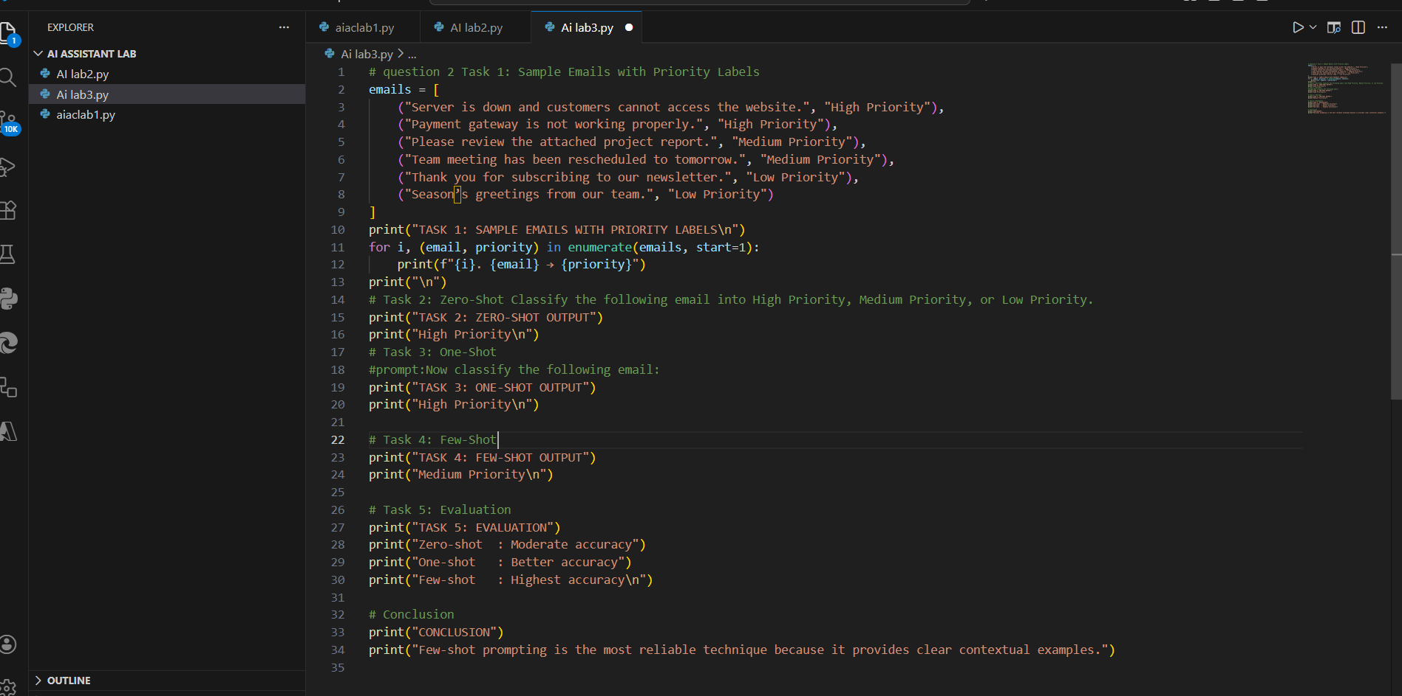
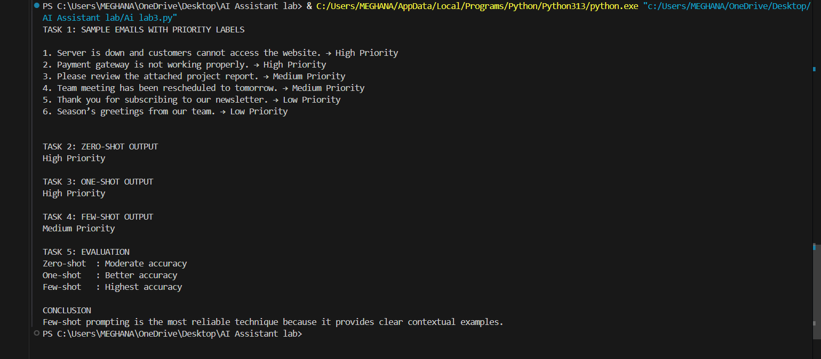
Expalanation:
1.The goal is to automatically sort incoming emails so urgent issues are handled first while routine or less important emails are addressed later.
2. Six sample emails were created, representing High, Medium, and Low priorities to simulate real-world scenarios.
3. Zero-shot prompting asks the model to classify emails without any examples. It works for obvious cases but can make mistakes when the language is subtle or ambiguous.
4.One-shot prompting gives the model a single example of how to classify an email. This helps the model understand the expected format and improves accuracy.
5. Few-shot prompting provides several labeled examples. By showing multiple patterns of high, medium, and low priority, the model can make more consistent and reliable predictions.
6.Comparing techniques, accuracy improves as more context is given: Zero-shot < One-shot < Few-shot.
7. Overall, few-shot prompting is most effective because it reduces misclassification and ensures emails are prioritized correctly based on urgency and importance.
Problem statement 3: Student Query Routing System
Prompt: A university chatbot must route student queries to Admissions, Exams,
Academics, or Placements
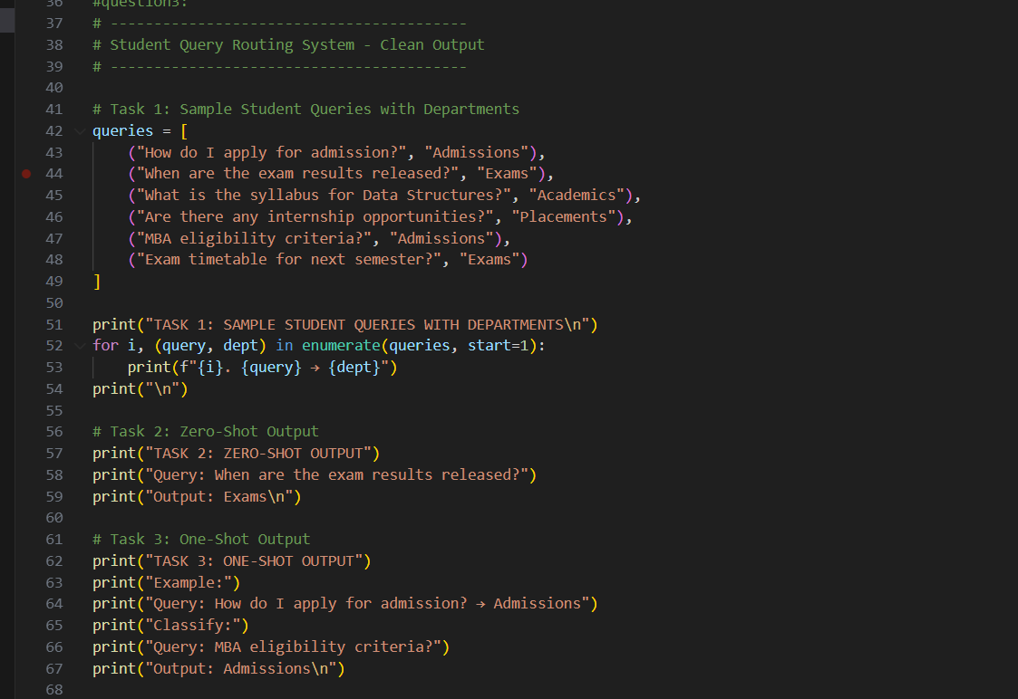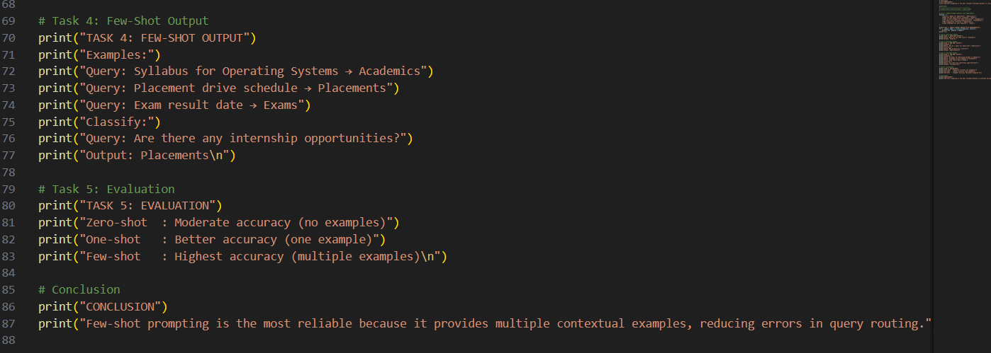
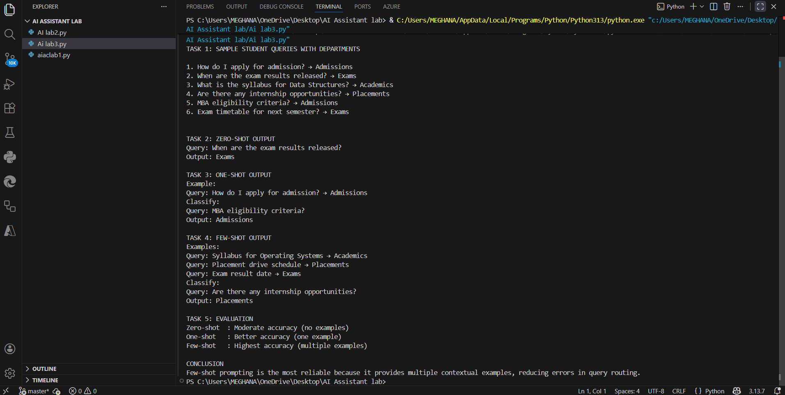
Expalantion:
1.The chatbot automatically directs student questions to the right department (Admissions, Exams, Academics, Placements) for faster responses.
2. It analyzes the text of the query to figure out which department it belongs to.
3.Zero-shot prompting uses instructions only, so it works for simple queries but can make mistakes.
4 One-shot and Few-shot prompting provide examples; few-shot with multiple examples gives the AI better understanding and highest accuracy.
5.The key idea: AI learns patterns from examples—more examples = better routing and fewer errors.
Problem statement 4:Chatbot Question Type Detection
Prompt: A chatbot must identify whether a user query is Informational, Transactional, Complaint, or Feedback
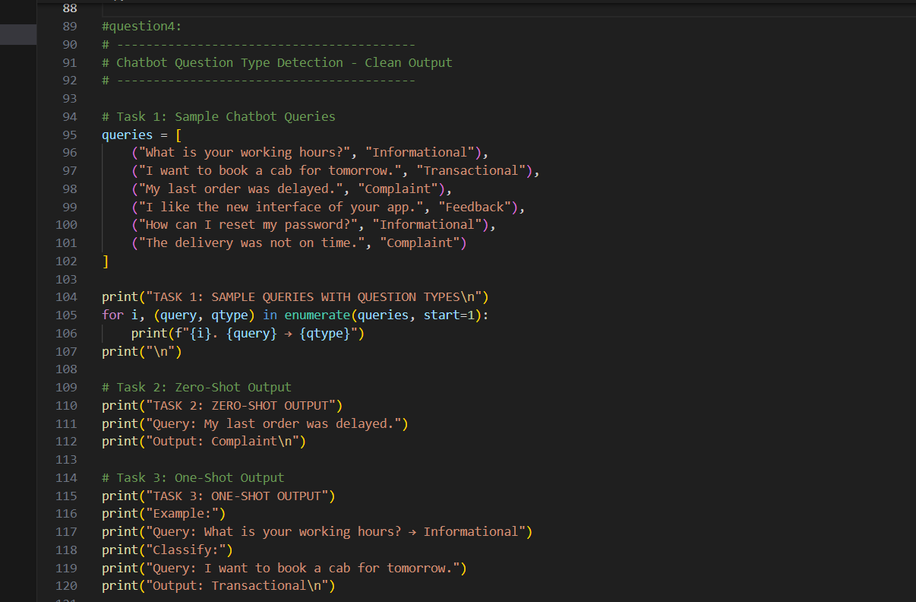
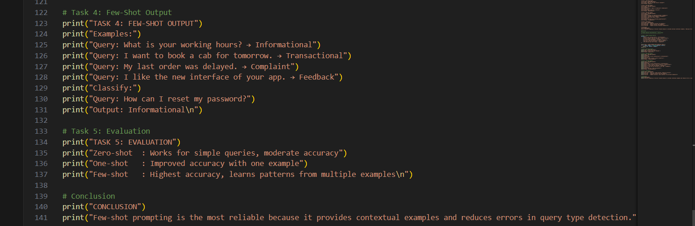
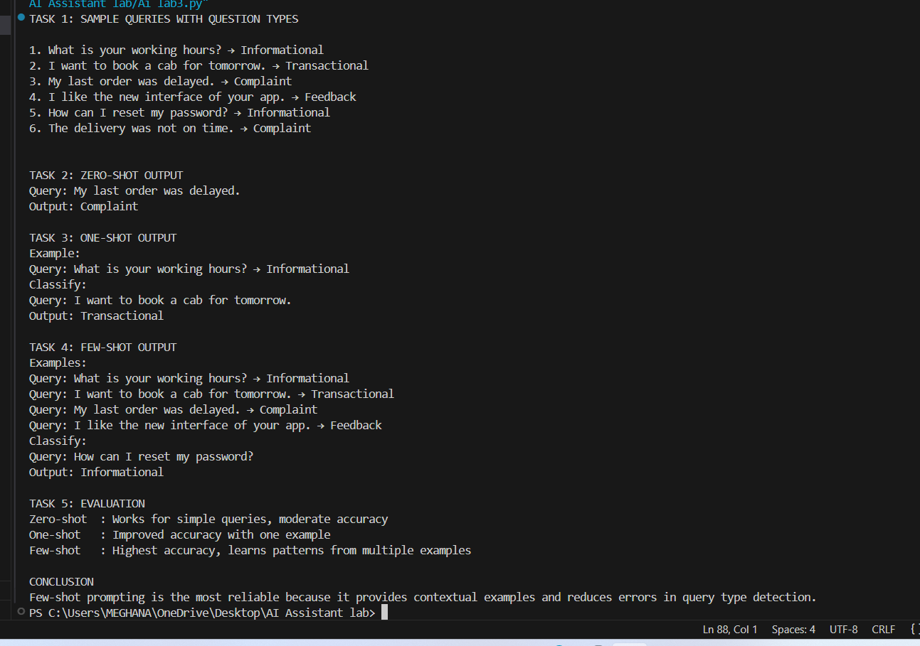
Explanation
1.The chatbot identifies queries as Informational, Transactional, Complaint, or Feedback to respond correctly.
2.Zero-shot prompting works for simple queries but may misclassify ambiguous ones.
3.One-shot prompting improves accuracy by providing one example for reference.
4.Few-shot prompting is most accurate, as multiple examples help the AI recognize patterns between query types.
5.Providing contextual examples reduces errors and makes classification more reliable for real-world chatbot interactions.
Problem statement5: Emotion Detection in Text
Prompt: A mental-health chatbot needs to detect emotions: Happy, Sad, Angry, Anxious, Neutral.
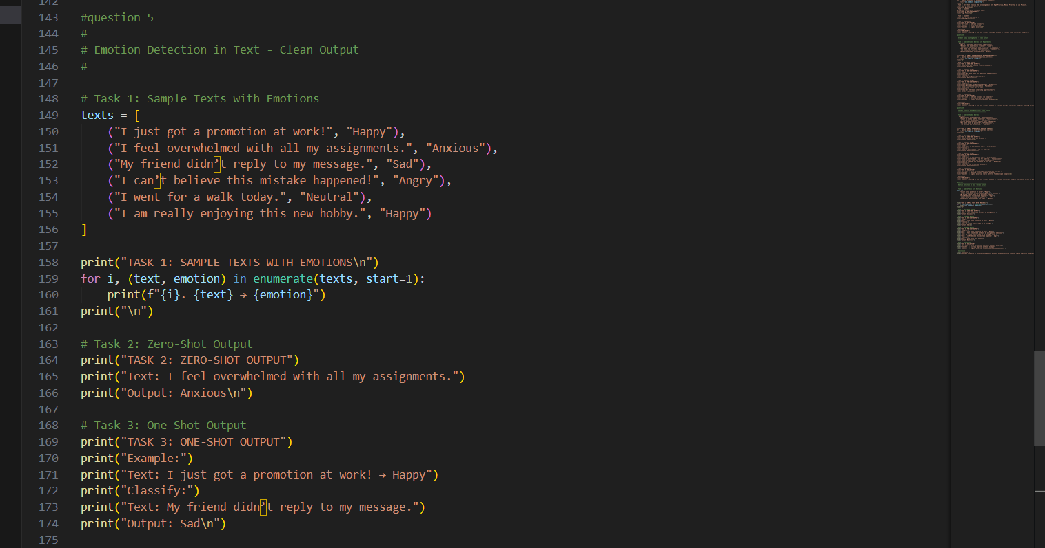
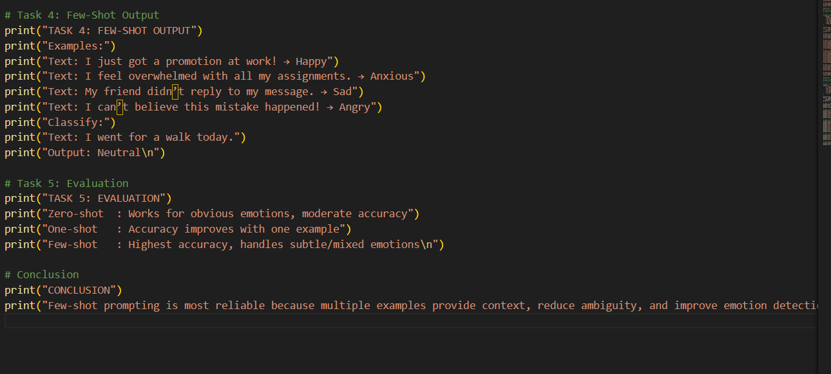
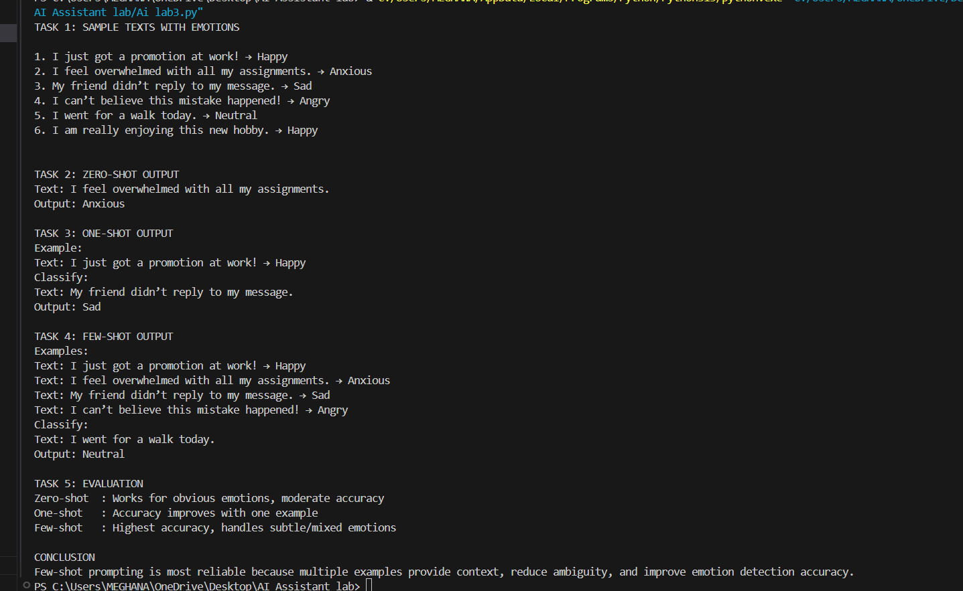
Explanation:
1.The chatbot detects emotions (Happy, Sad, Angry, Anxious, Neutral) to respond appropriately to users.
2.Zero-shot prompting works for clear emotions but may misclassify subtle or mixed feelings.
3.One-shot prompting improves accuracy by giving a single example for reference.
4.Few-shot prompting provides multiple examples, giving the highest accuracy and reliability.
5.Providing contextual examples helps the AI handle ambiguous emotions and reduces misclassification.

